**TASK 1. Create an S3 Bucket:**

**1. Create a new S3 bucket with a globally unique name.**

**2. Configure bucket policies and access control lists (ACLs) to control permissions.**

**3. Enable versioning for your S3 bucket.**

**4. Upload, modify, and delete objects to observe versioning in action.**

**Steps to create a new S3 bucket with a globally unique name:**

1. Search S3 in the console home and open the S3 console

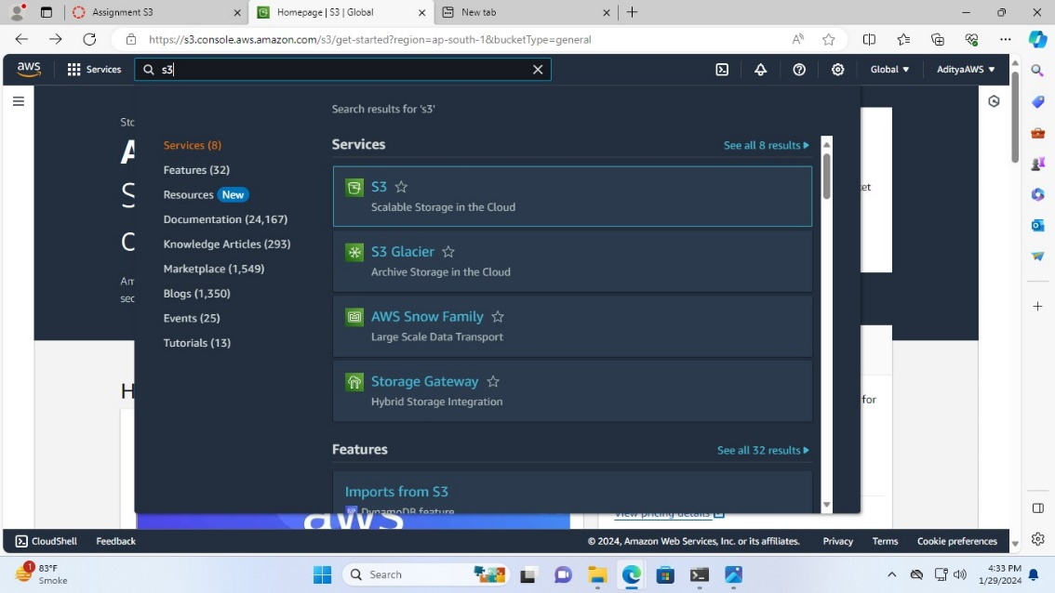

1. In the S3 console click on “Create bucket”

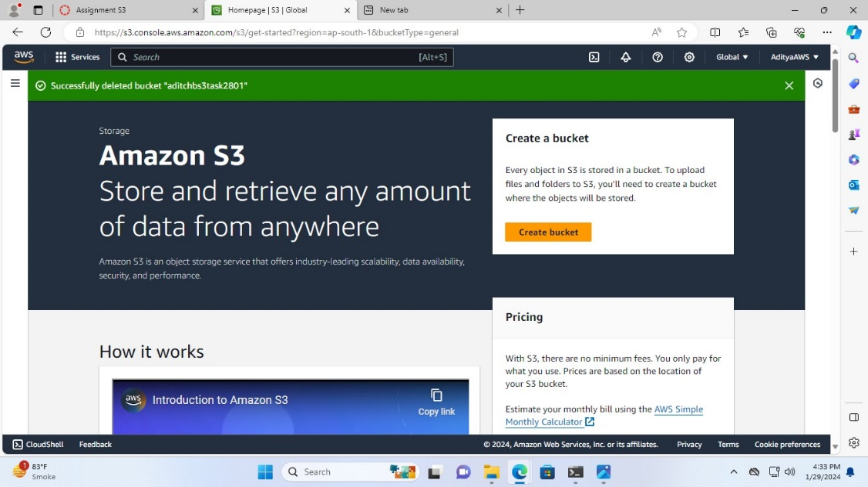

1. Select the AWS region and name the Bucket that should be globally unique (I have named it “tasks3bucketaditya”)

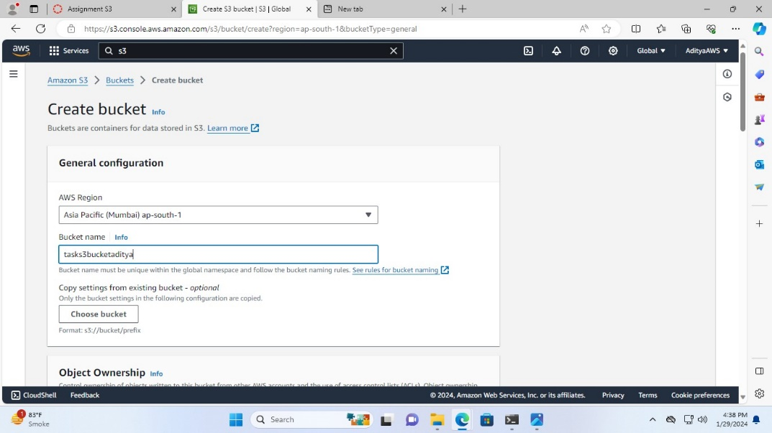

1. Enable the Bucket Versioning

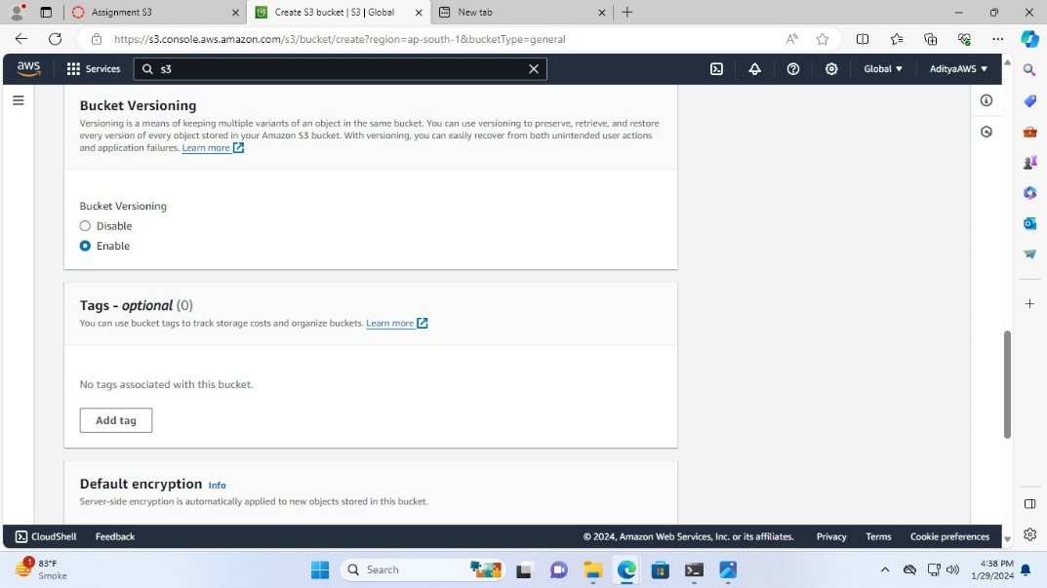

1. Click on “Create bucket”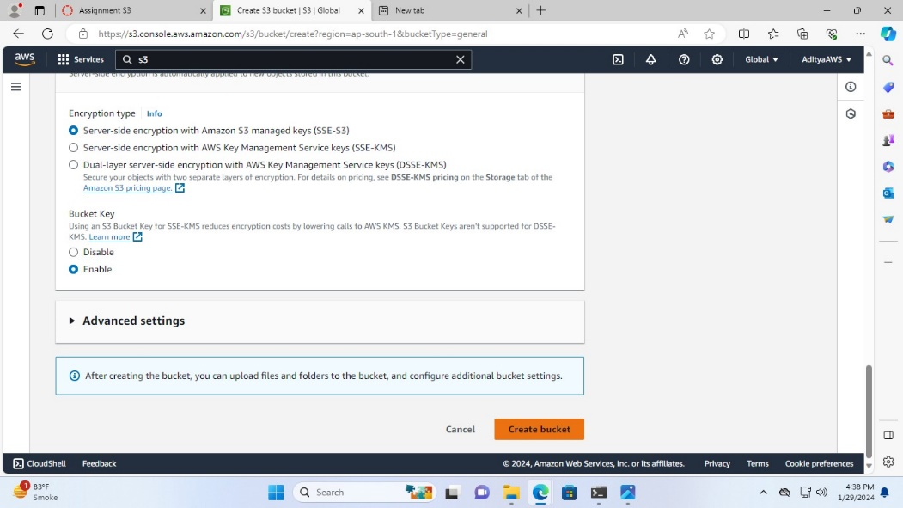

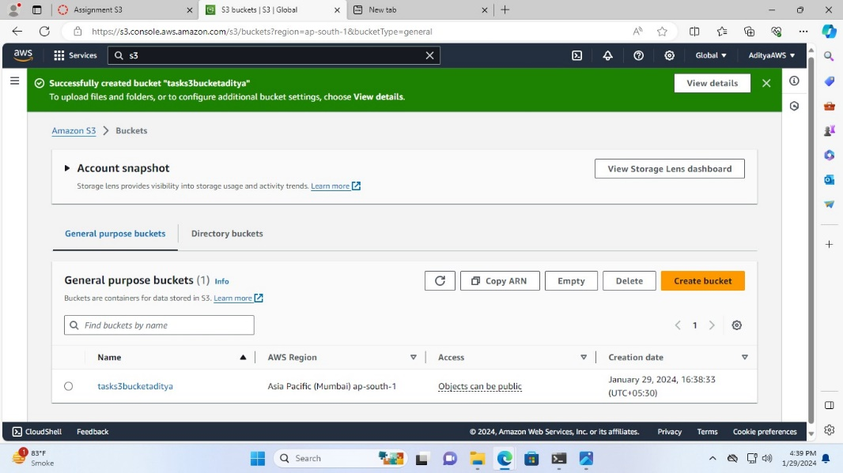

**Editing public access:**

1. Click on the “task3bucketaditya”

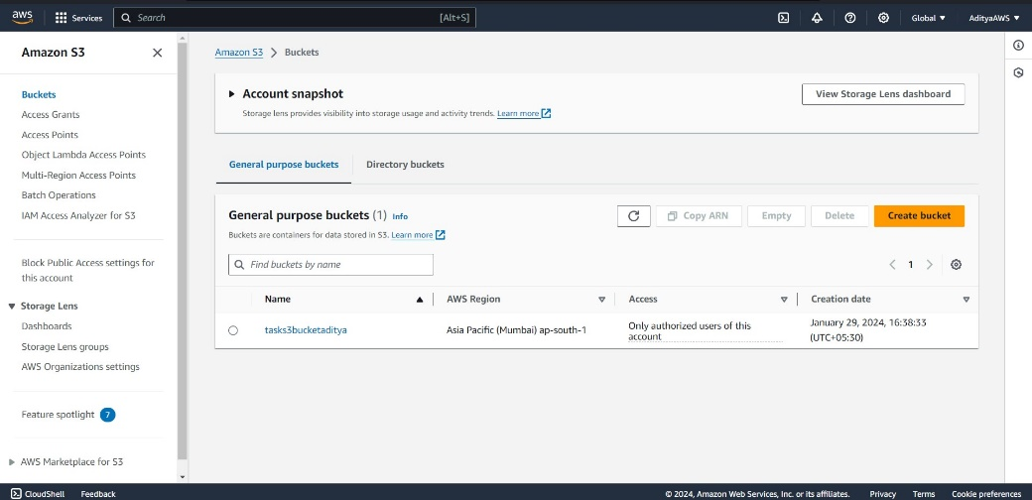

1. Then go to the permissions and click on “Edit” in the Block public access section

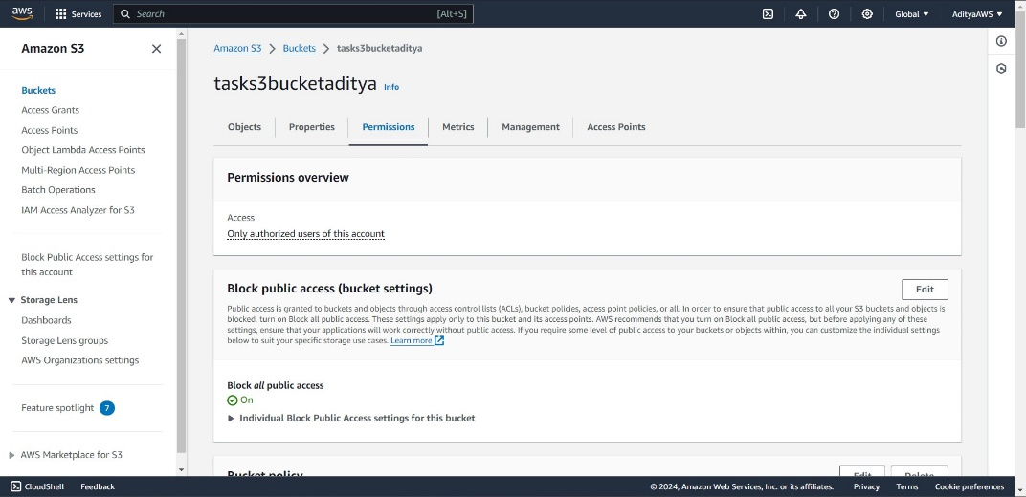

1. Now, untick the Block all public access, click on “Save changes” and type confirm and click on “Confirm”

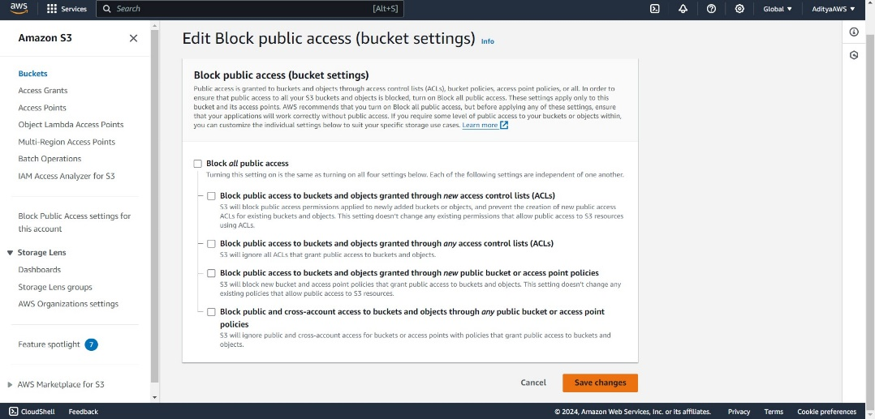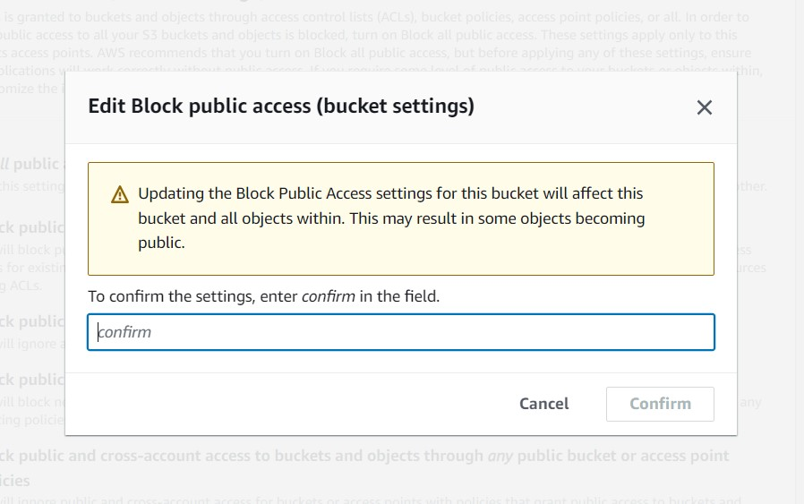

And now, it is publicly accessible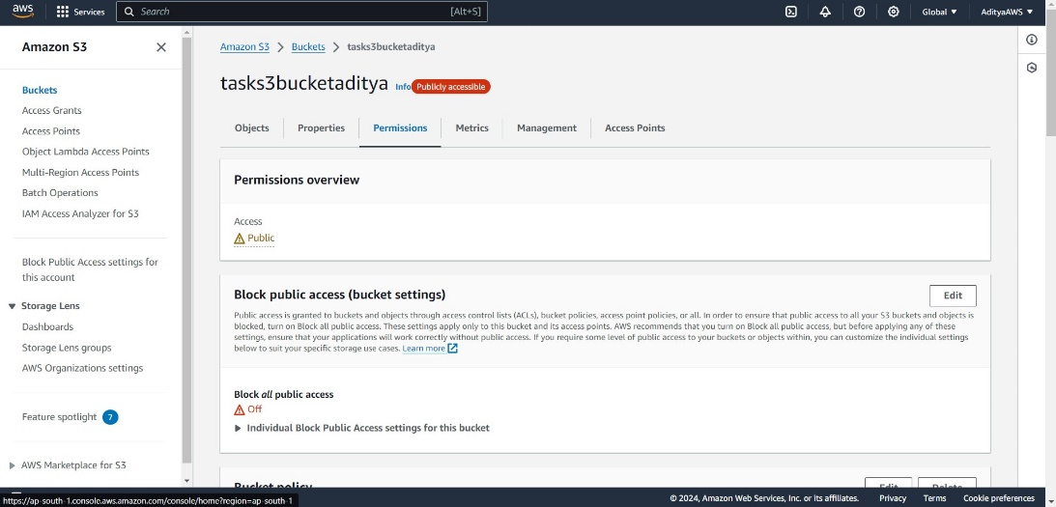

**Now, to configure bucket policies:**

1. Scroll down in permissions and go to the Bucket policy, click on “Edit”.

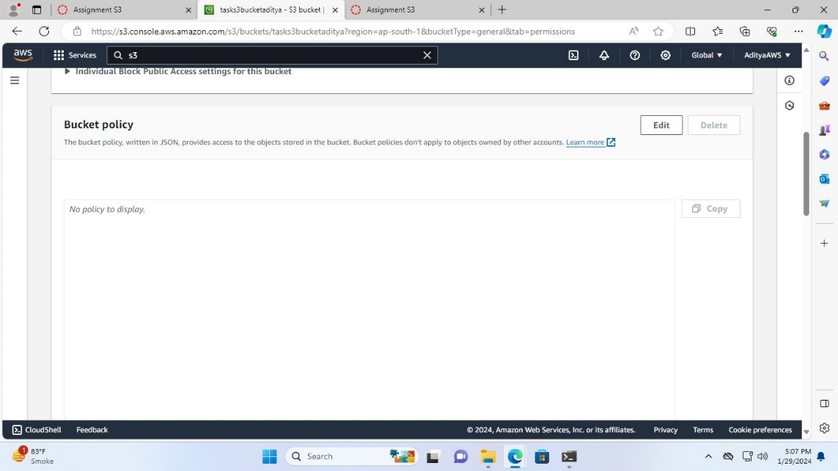

1. In the Edit bucket policy tab click on “Policy generator”

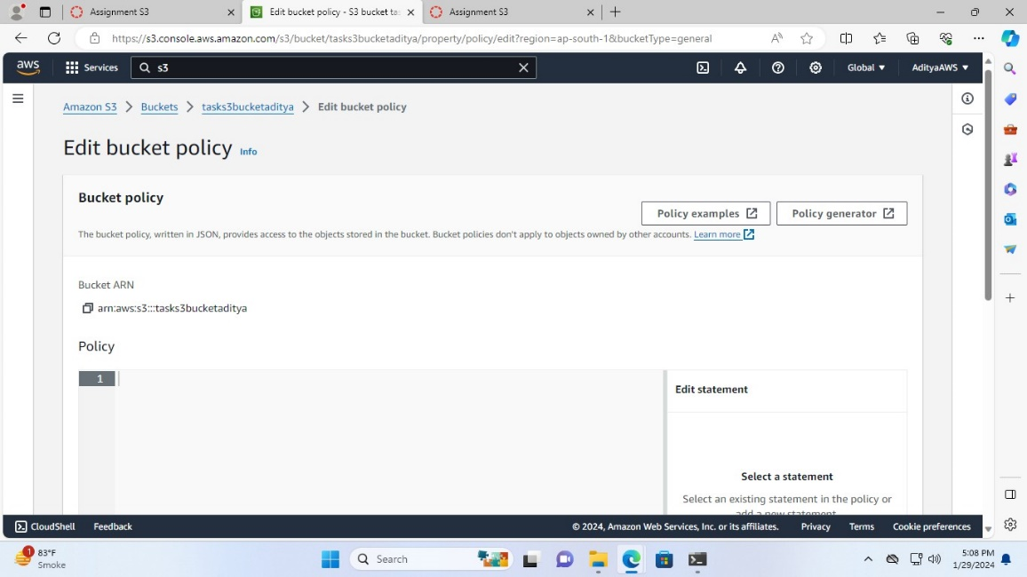

1. Now in AWS policy generator tab

Select S3 Bucket Policy in type of Policy

In Principal fill “*”

In Actions select “GetObject”

In ARN : aws:s3:::tasks3bucketaditya/*

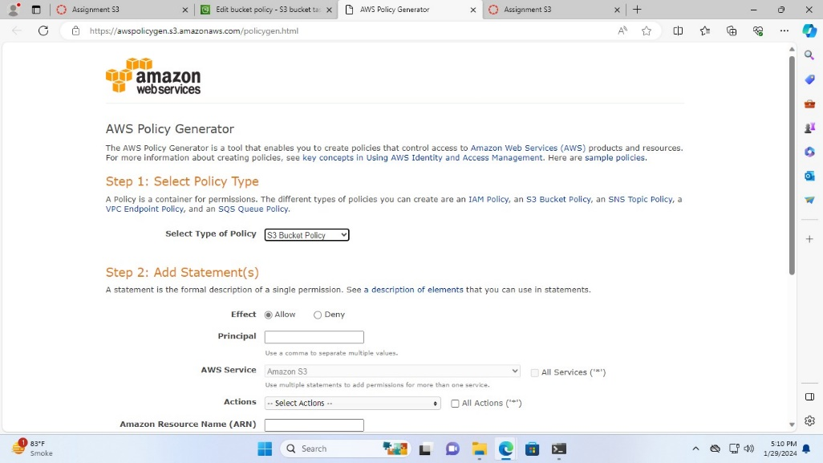

1. Then, click on “Add Statement”

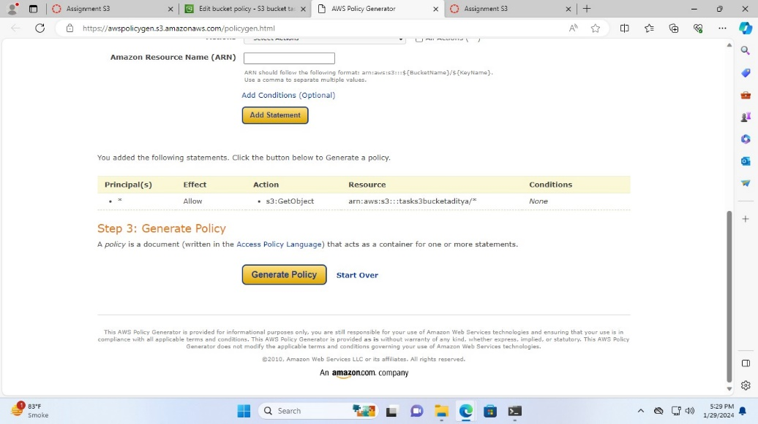

after this, click on “Generate Policy”

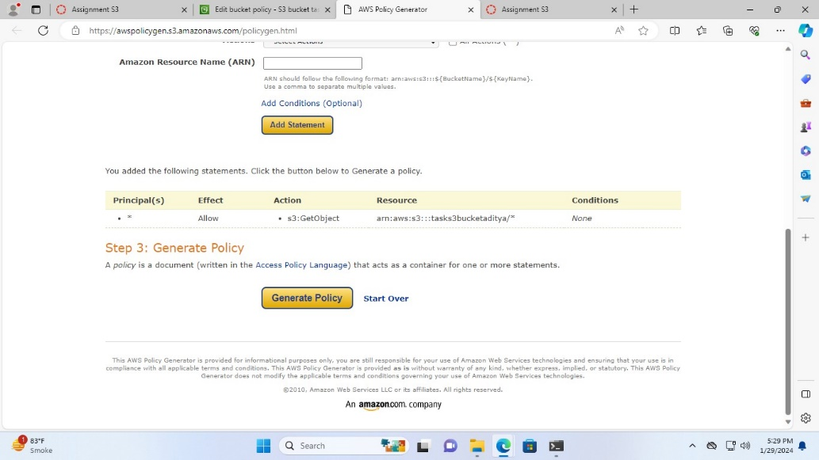

1. Copy this JSON Document

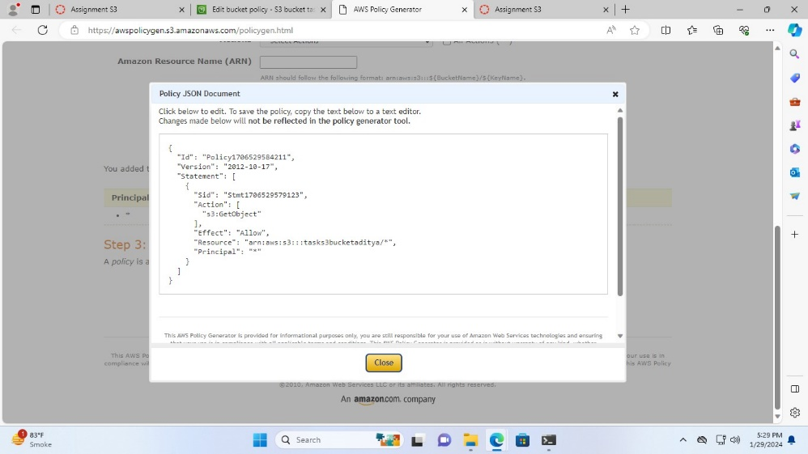

Then, paste it to the Policy in the Edit bucket policy tab and click on “Save changes”

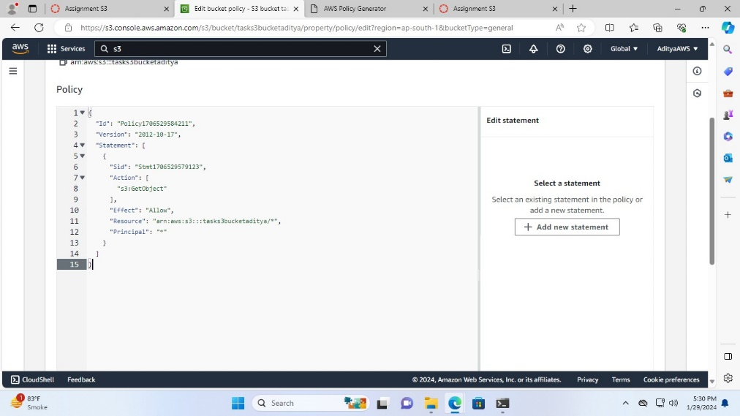

Successfully edited bucket policy

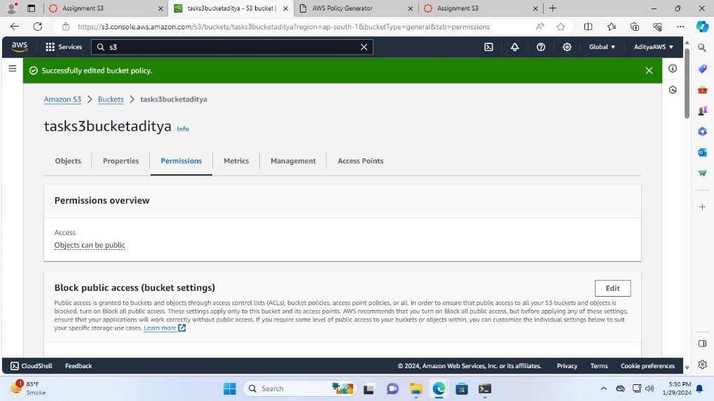

**Configuring access control lists (ACLs):**

1. Scroll down and go to the Access control list (ACL)

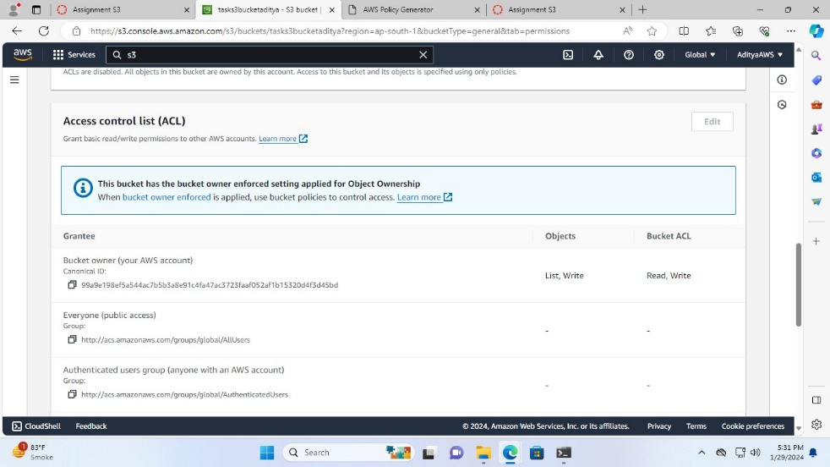

1. In order to edit the Access control list we need to edit the object ownership we have to

select “ACLs enabled” and click on “Save Changes”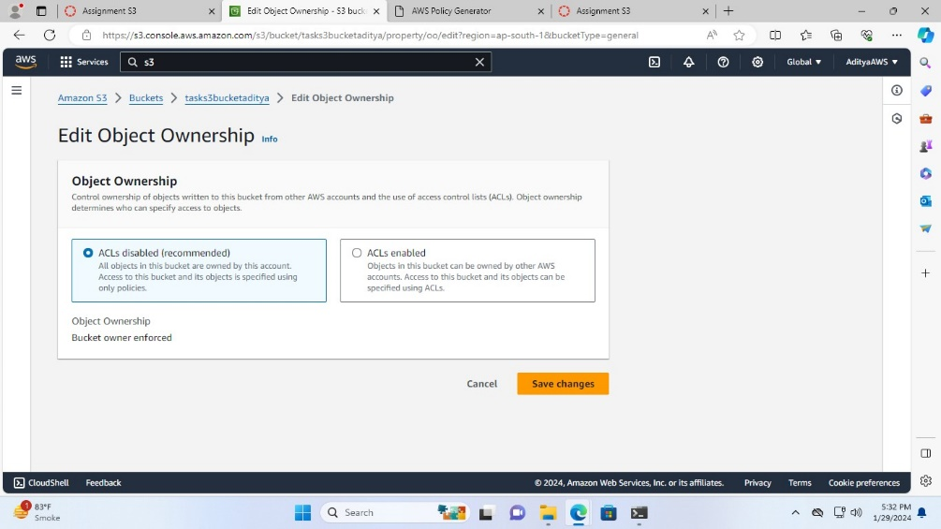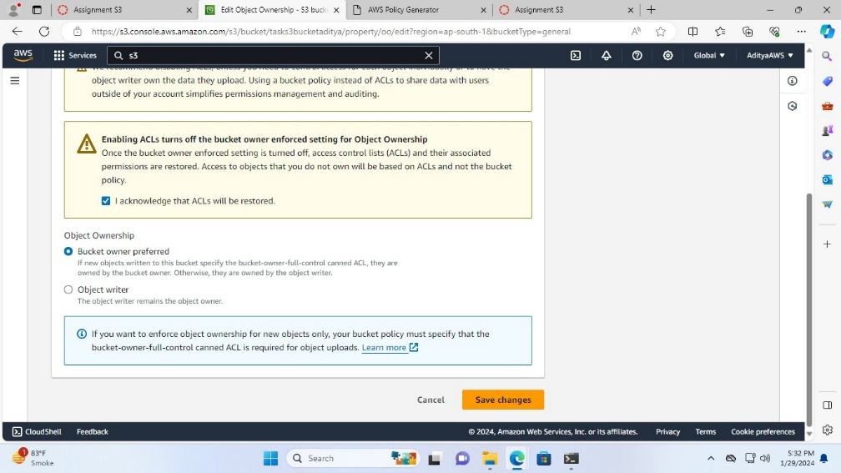

1. Now, we can edit the access control list so here tick the List and Write in objects and tick Read and Write in Bucket ACL for the Bucket owner

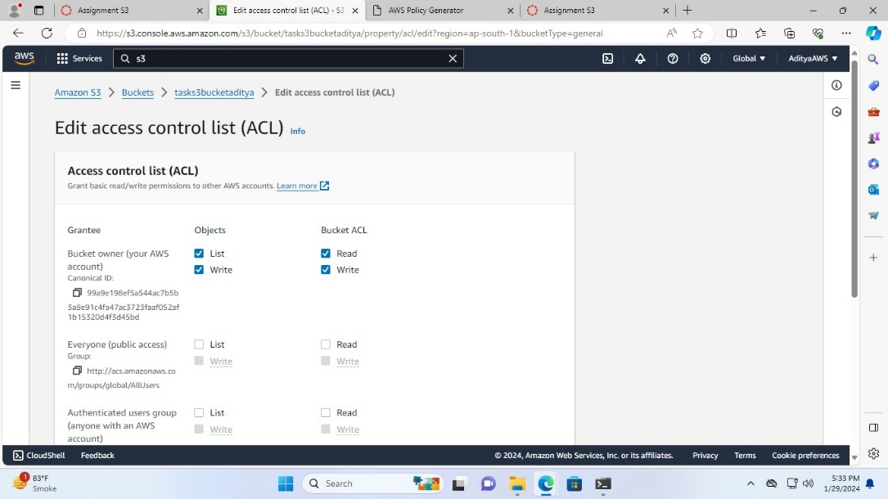

Then, click on “Save changes”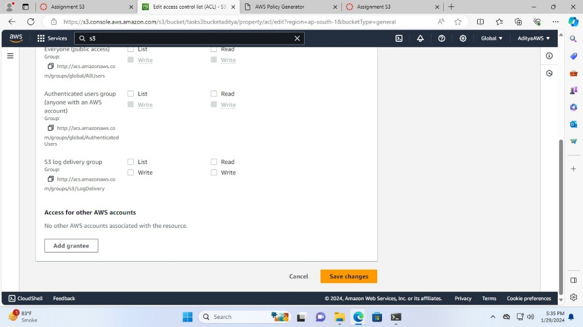

Successfully edited ACL

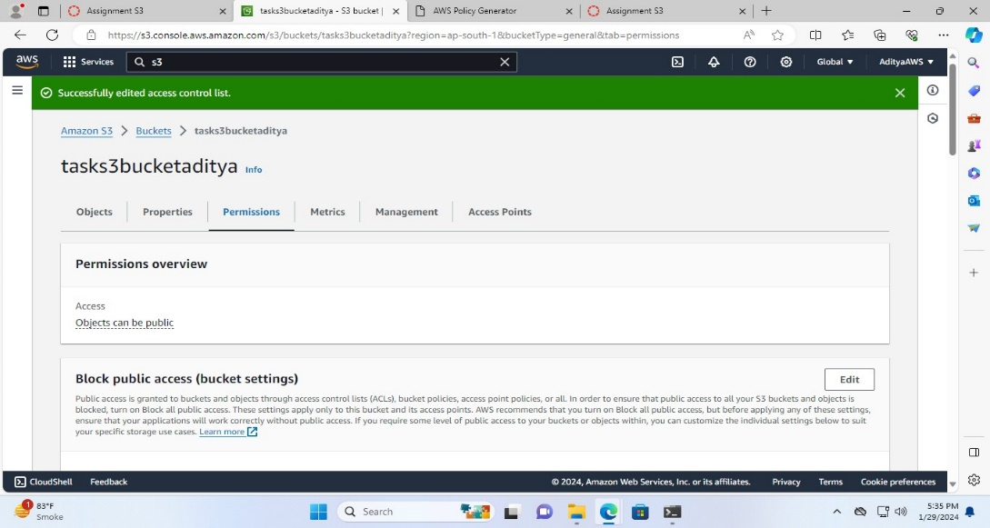

**Upload, modify, and delete objects to observe versioning in action:**

**To upload image:**

1. In the bucket (tasks3bucketaditya) click on “Upload”

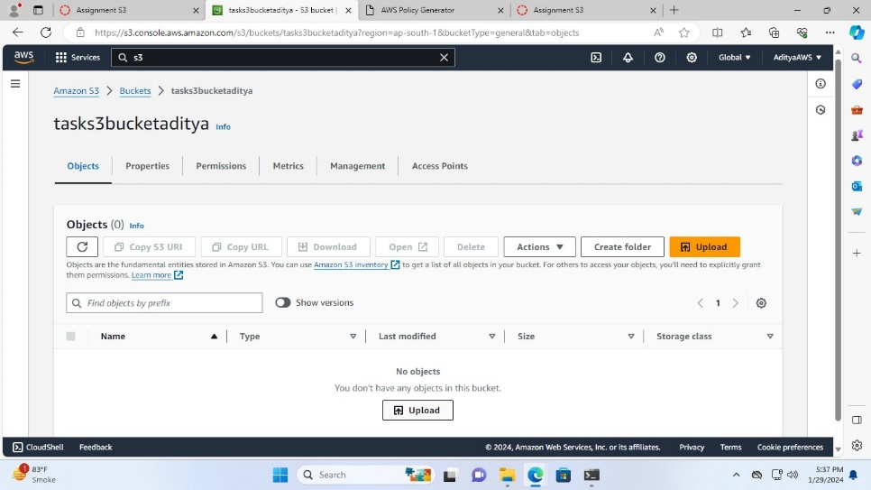

1. Add the file or drag and drop files and the folders you want to upload

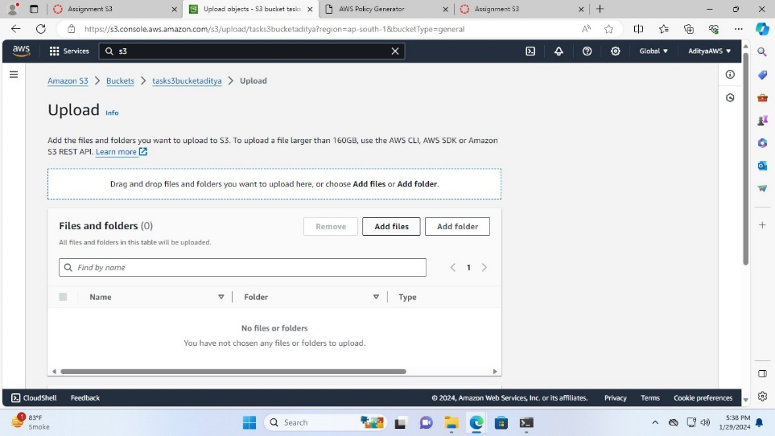

Then, click on “Upload”

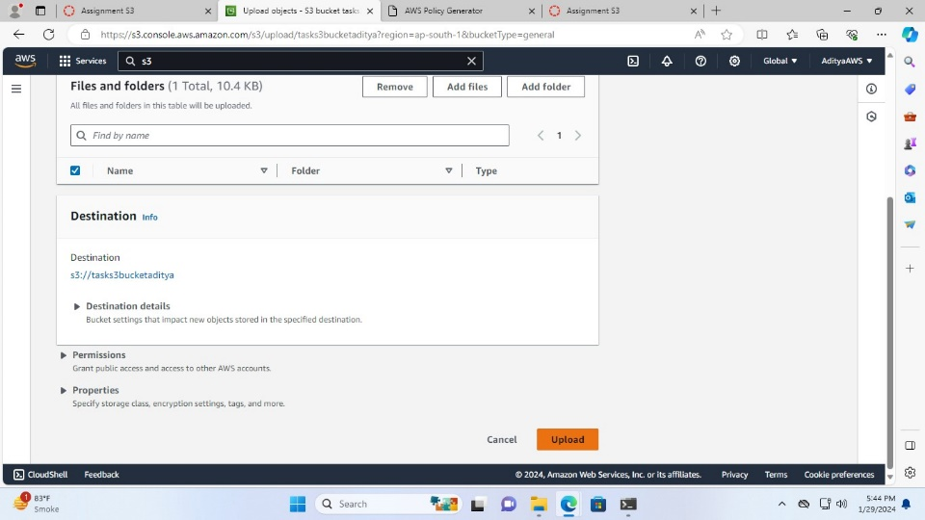

I have uploaded the file named “spiderman.jpg”

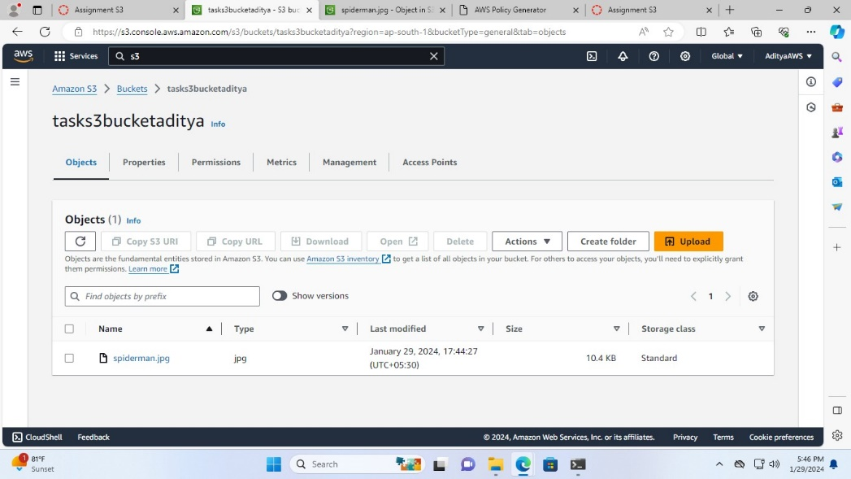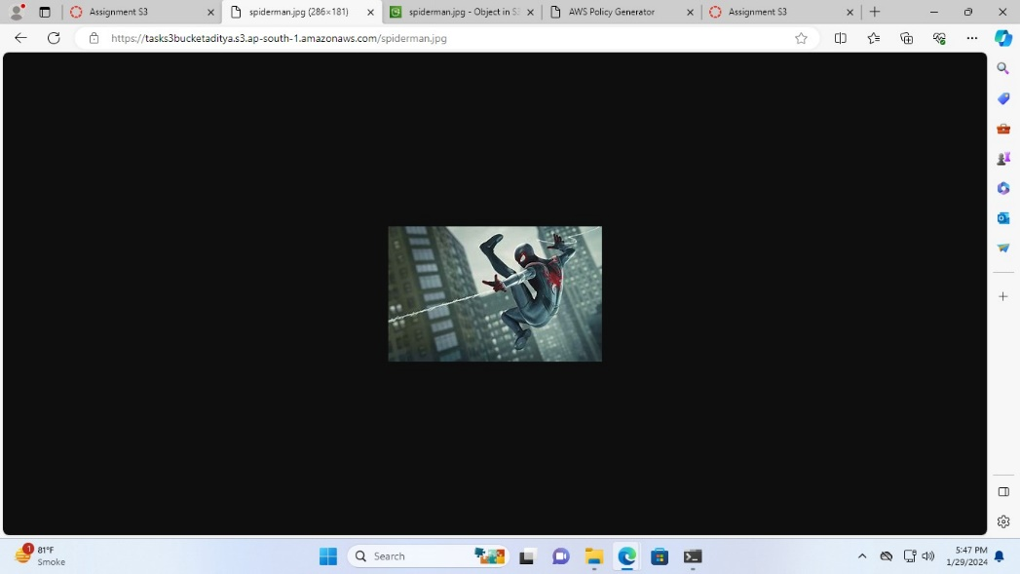

**To modify image:**

1. Now, upload the different image with the same name (spiderman.jpg)

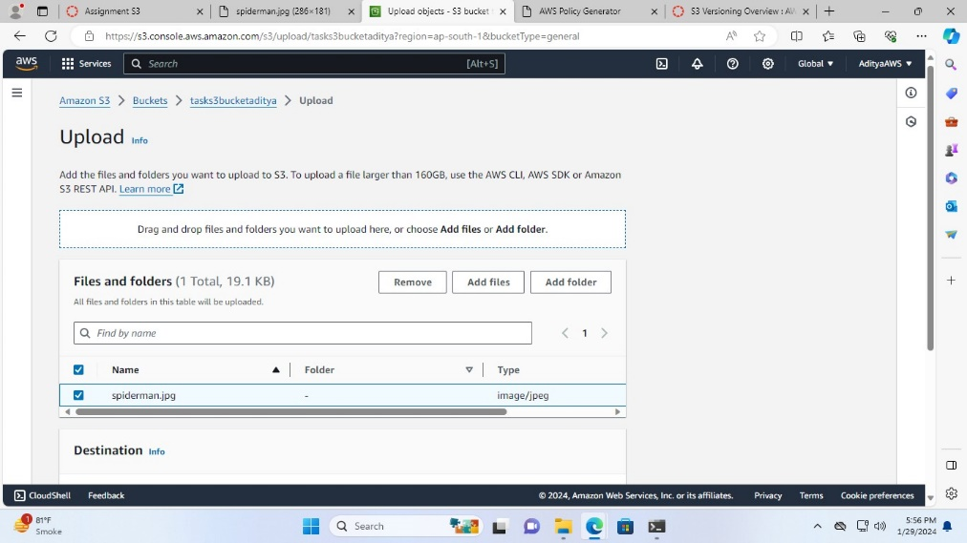

Now, it is modified

From this:



To this:

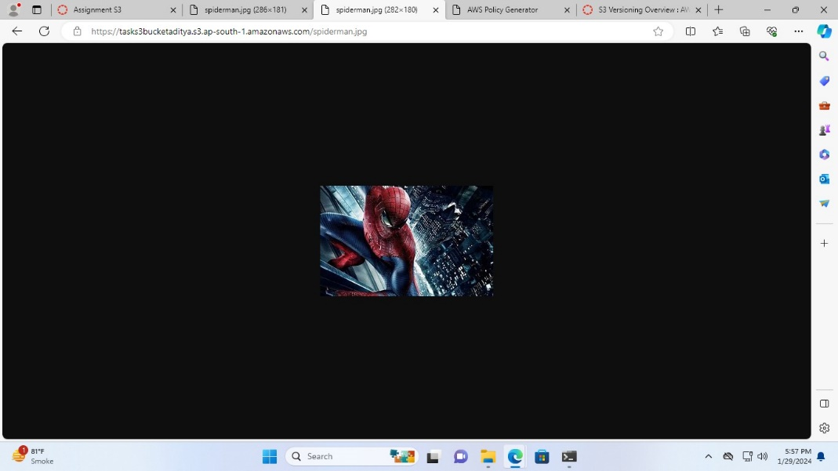

**To delete:**

1. To delete the file select the file and click on “Delete”

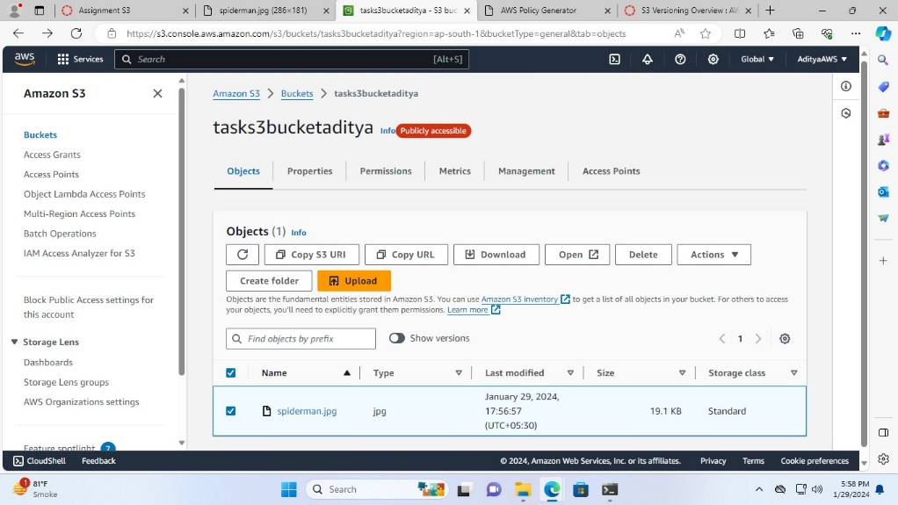

1. Now, type delete and click on “Delete objects”

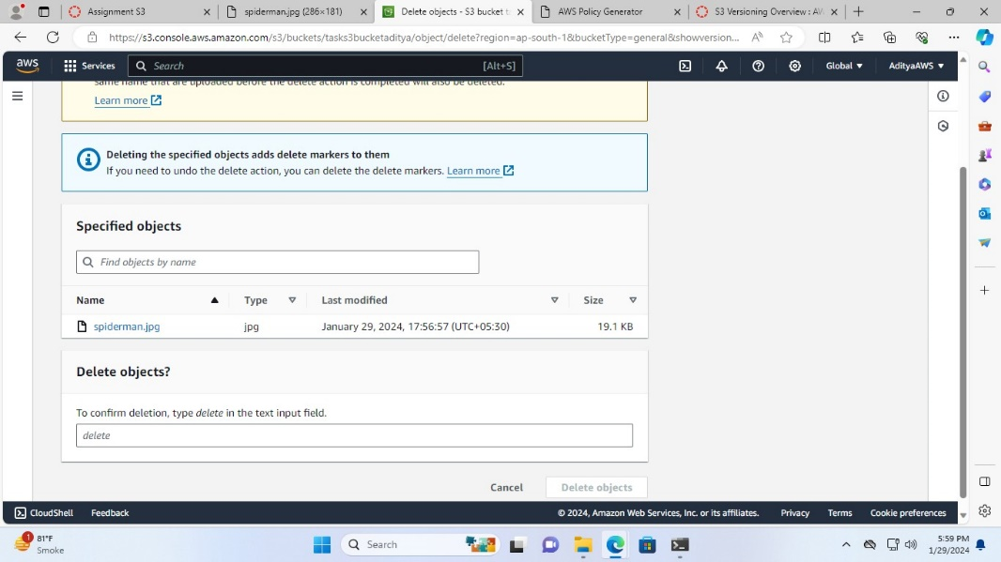

Successfully deleted objects